Introduction

Urban living conditions vary widely across major U.S. cities, shaped by factors such as education, commute time, healthcare, income, and housing affordability. As New York City, Boston, and San Francisco continue to attract diverse populations and high-skill workers, understanding how these cities differ in overall quality of life has become increasingly important. This project aims to provide a data-driven comparison of these three metropolitan areas using publicly available datasets from dataUSA, American Community Survey (ACS), Zillow housing data, and other census sources.

Our analysis focuses on four key indicators that reflect everyday living conditions: higher-education attainment, average commute time, health insurance coverage, and comparison of median income and housing price. Each team member examined one of these indicators, and together they form a cohesive framework for evaluating quality of life across the selected three cities.

Using Python for data importing, cleaning, transformation, and visualization, we combined multiple datasets. Each selected dataset contains thousands of records that help explain the strengths and constraints of each city. Our goal is not only to compare the three cities across these metrics, but also to build a clear narrative that highlights how these factors interact to influence residents’ overall lives.

This report presents our findings, visualizations, and interpretations, offering a data-driven perspective on how quality of life differs among New York City, Boston, and San Francisco.

Challenges Encountered During Development

One of the biggest challenges we faced during this project was determining an appropriate research scope and identifying reliable datasets to support our analysis. Our initial plan was to compare 10 different cities across 6 indicators. Professor Javaly pointed out that the amount of data required to support a broad study was beyond what we could reasonably collect and process. After confirming with the professor, we decided to narrow the project to three cities and four key indicators, which made the analysis more manageable.

The data collection process itself also presented significant difficulties. For each indicator, we needed to ensure that the datasets were not only from valid sources but also that the internal contents were sufficiently detailed to support meaningful analysis. Many of the datasets we initially found lacked specific variables. We had to repeatedly confirm whether a dataset was usable before incorporating it into our workflow.
Overall, the most challenging part of the project was not the analysis itself, but rather finding, validating, and preparing the right data. Once the data issues were resolved and the scope was properly refined, the Python analysis and visualization became much more straightforward.

Description of Data Preparation
To prepare our data, we used the Jupyter Notebook Colab environment. The preparation of data for each question answered in this project is as follows:
- Means of Commuting Dataset: CSV files were loaded from our shared Google Drive folder. The Jupyter notebook reads each city’s file, appends them into a single dataframe, and adds columns identifying both the source file and the city to enable cross-city comparisons. After verifying structure through shape checks and random samples, the notebook computes share variables to express each commuting category as a proportion of the total for each city.
- Average Commuted Time Dataset: A similar process is used for the average commute-time data: each city’s file is read in, shapes and samples are inspected for consistency, and the datasets are then concatenated and de-duplicated to create a unified table of travel-time categories by year and city.
- Health Insurance Coverage Comparison: For the health insurance section, the code combines Kaiser coverage-by-age data across years and cities, then filters to the specific years of interest (2020-2023) to focus on recent trends. It engineers an “Insured Share” variable by subtracting the uninsured percentage from 100, producing parallel columns for uninsured and insured shares by age group and city. Sample rows are displayed after each key step (combining, filtering, and creating new columns) to validate that the transformations worked as intended and that the resulting tables have the expected structure and values.
- Housing Price vs. Median Income Comparison: Data preparation for the housing price vs. median income analysis included verifying that the different datasets were properly aligned, creating a dataframe that identified each city’s median income, and cleaning the Zillow data to produce a usable housing-price dataframe. After these steps, the income and housing-cost information were merged into a single combined dataframe for comparison.
- Education Attainment Comparison: Data preparation for educational attainment involved filtering the dataset to retain only relevant rows and columns, cleaning the data by dropping missing values to prevent errors, and calculating a population-weighted average for New York City. This weighting ensures that the city’s diverse boroughs are appropriately represented, allowing for a fair comparison with Boston and San Francisco.

Answer to Initial Questions

Overall, our results show that New York, Boston, and San Francisco all have high insurance coverage and relatively high incomes, but they differ markedly in commuting patterns, housing cost pressures, and the level of educational attainment of their populations.

In 2023, New York City stands out in transit use: about 46% of commuters relied on public transportation, far exceeding Boston (~24%) and San Francisco (~21%). Driving alone was most common in Boston (about 34%), followed by San Francisco (~29%) and New York (~22%). San Francisco had the highest share of people working from home (~27%, compared with ~19% in Boston and ~15% in New York), while Boston held a slight lead in walking and cycling rates.

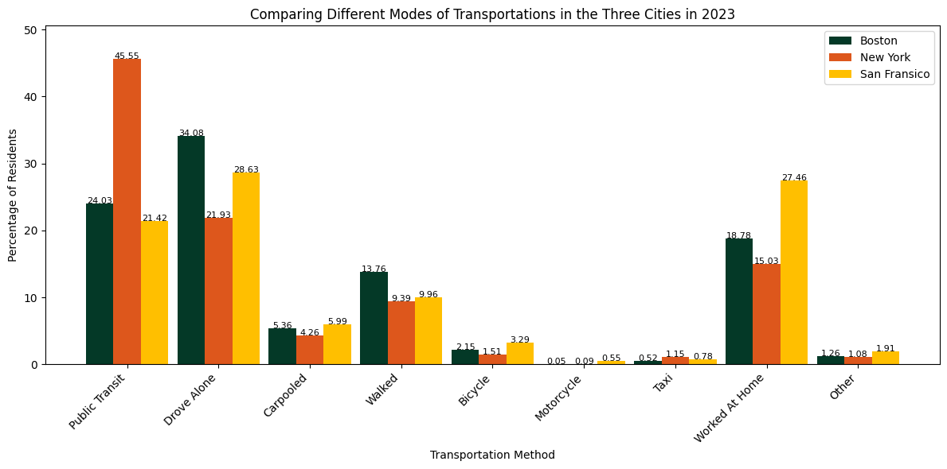

A larger share of residents in these cities have commutes longer than 30 minutes compared with the U.S. average. In New York City, the average commute for most residents exceeds 35 minutes, with about 18% commuting 60–89 minutes daily. In Boston and San Francisco, the distribution of commute times is broadly similar to each other. It is important to note that New York City is geographically much larger (over 300 square miles) compared with Boston (89.6 square miles) and San Francisco (46.89 square miles), which contributes to longer travel times. 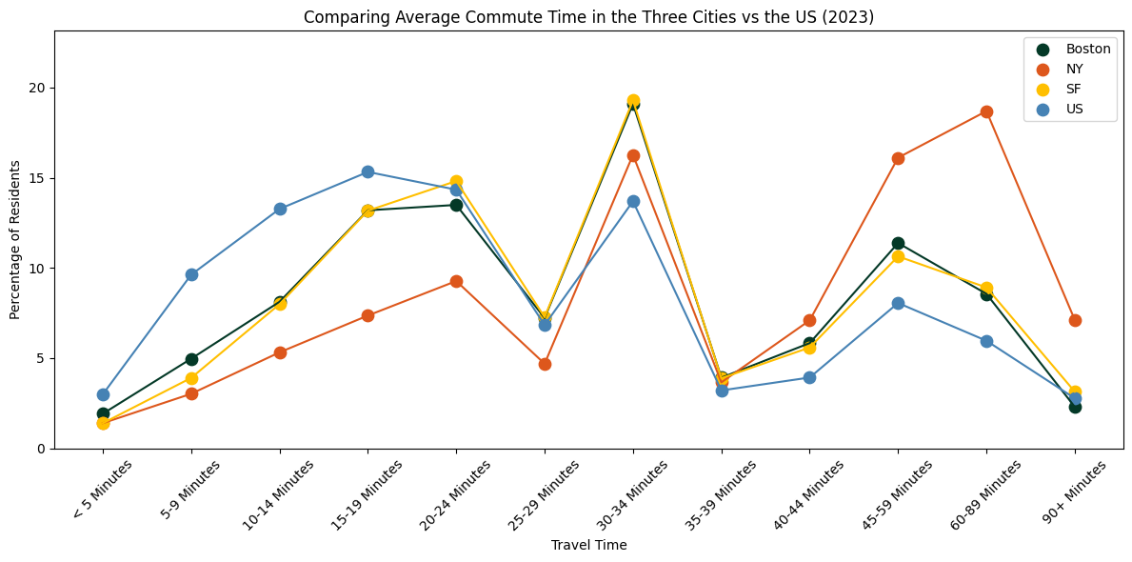

The cleaned Boston survey shows extremely high insurance coverage: roughly 98% of the total population is insured, with children and older adults essentially at or near full coverage. The NYC and San Francisco datasets (NYC EH Portal and CityHealthDash) similarly show insured rates in the mid- to high-90% range across age groups, indicating that all three cities maintain a strong coverage floor. Differences appear more by age group and coverage type (public vs. private) than by the city itself.

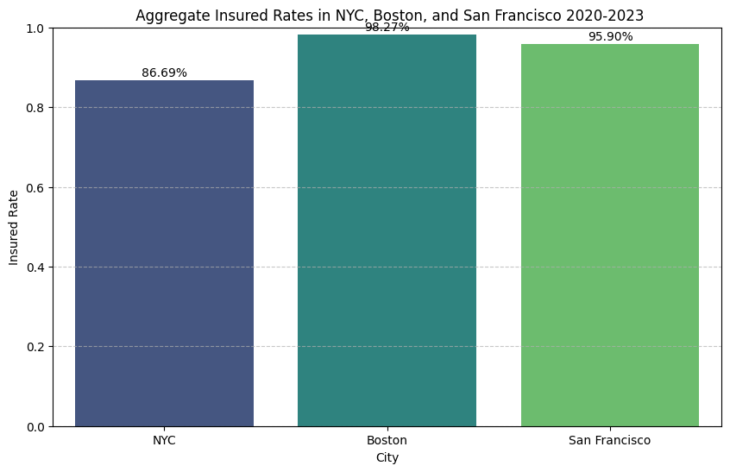
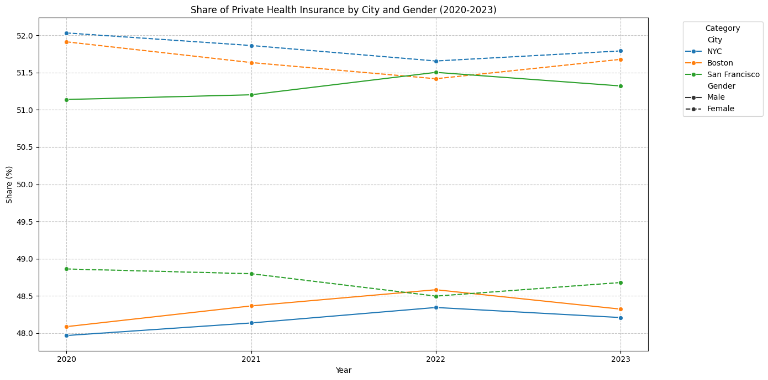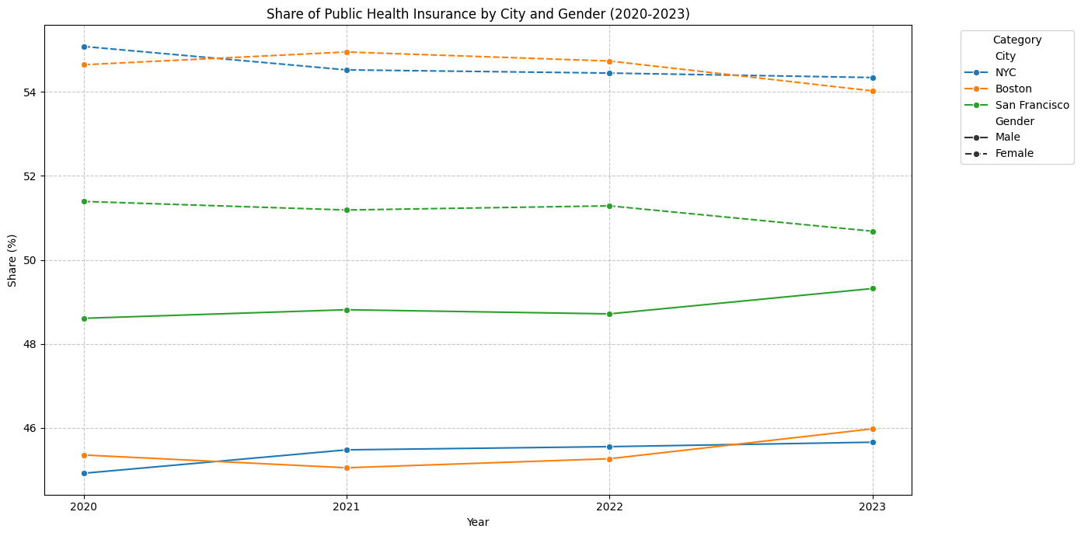
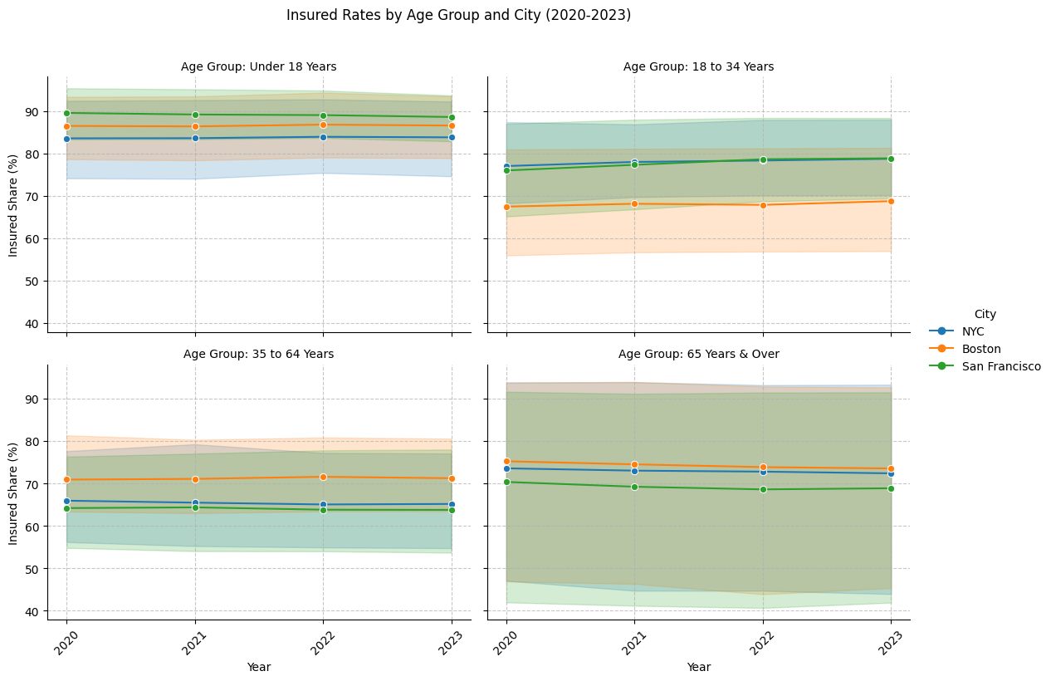We found that housing is most expensive in San Francisco, where the median home price is about $1.1 million, compared with roughly $657,000 in Boston and $635,000 in New York City. Median incomes are much lower than home values in all three cities, but the gap is widest in New York (about $82,000 vs. $635,000) and Boston (about $93,000 vs. $657,000). San Francisco’s much higher median income (around $145,000) helps narrow, but does not eliminate, the strain created by its exceptionally high housing costs.
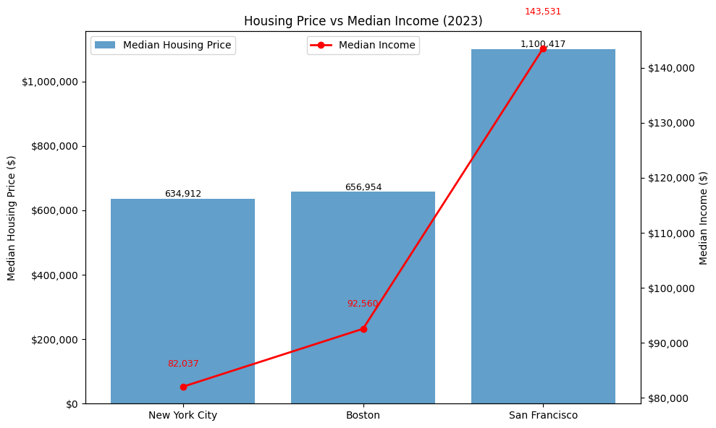

In terms of bachelor’s degree attainment among adults age 25 and over, San Francisco ranks highest, with 60.1% of residents holding a bachelor’s degree or higher. Boston follows at 49.7%, while New York City trails at 32.1%. These differences may reflect San Francisco’s concentration of tech firms that demand highly educated workers, as well as Boston’s dense cluster of universities and research institutions.
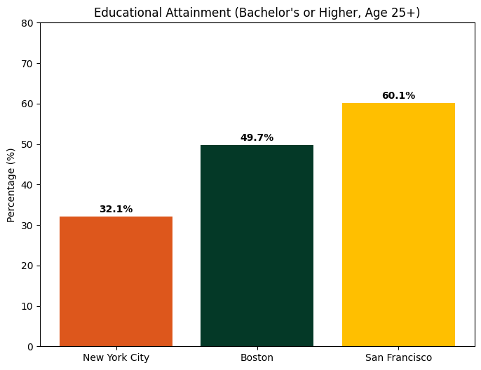

What We Learned During the Project Development

Working on this project helped us understand how much of data analysis depends on defining the right scope and finding usable data. In the beginning, we planned to compare many more cities and indicators, but once we started searching for datasets, it became obvious that our original idea wasn’t realistic. Narrowing the project down—after talking with the professor—made the work more focused and manageable, and it taught us how important it is to balance research goals with time and data availability.

A major lesson was that collecting and verifying data often takes more time than the actual analysis. Many datasets looked promising at first, but didn’t include the variables or level of detail we needed. We had to double-check sources, confirm definitions, and make sure that measures were comparable across cities. This process forced us to slow down, rethink our assumptions, and make sure we were building our analysis on solid ground.

On the technical side, we got much more comfortable using Python for real data work. We learned how to import and clean multiple datasets, inspect them carefully, merge them properly, and create new variables that allowed us to compare the three cities on equal terms. Repeatedly checking shapes, sample rows, and summary statistics helped us catch issues early and build more confidence in our code.

Finally, we learned a lot about collaboration. Each of us worked on a different indicator, but our pieces still had to connect into one coherent analysis. Sharing code, discussing problems, and helping each other troubleshoot taught us how to coordinate effectively during a multi-step technical project. Overall, the development process showed us how technical skills, planning, and teamwork all come together in real analytics projects.

Helpful Resources

- CIS 9650 Course Materials (Slides, Notebooks, and Code Examples)
The class notes and walkthroughs guided most of the data preparation and visualization work. The examples on file handling, Pandas, merging data, and plotting in Python were especially useful when we were cleaning and combining datasets for each city. The earlier lectures on Python basics also helped us avoid common errors and kept our code organized and readable.

- Public Data Platforms (Data USA, ACS, Kaiser, Zillow)
These sites provided the core datasets for our analysis. Their documentation pages helped us understand how variables were defined and whether different cities’ numbers could be directly compared.

- Google Colab + Google Drive
Using Colab made it easy for all of us to run the notebook and share datasets without needing to install anything locally. The class instructions on connecting Colab to Drive made it straightforward to keep all of our files in one place.

- Official Documentation for Pandas, NumPy, and Matplotlib
Whenever we got stuck—especially with merging, reshaping data, or formatting visualizations—the library documentation helped us figure out the correct methods and parameters.

- Team Collaboration
A lot of troubleshooting happened simply by talking through issues with each other. Reviewing each other’s code, sharing alternative approaches, and checking outputs together made the project more accurate and more manageable.

Reflection
Overall, this project allowed us to learn how to source datasets from open platforms, assess their reliability, and adjust our project scope based on dataset scale and the time available to complete the work. We applied concepts learned in class, supplemented by additional resources, to create visualizations that effectively present key information and provide a comprehensive answer to our research questions.
We also divided tasks among team members and used role rotation to ensure that everyone contributed to various components of the project and gained broader experience. Each member focused on a specific question during the coding process, and we collaborated closely by sharing feedback and discussing progress during our weekly meetings. This combination of individual effort and group coordination strengthened both the quality of our work and our overall learning experience.
If we were assigned a similar project in the future, we would begin by conducting an initial exploration of the datasets much earlier. We would also start searching for datasets only after clearly defining the specific time frame and variables required for our analysis.
While it is understandable to come up with research questions that are broad in scope, if we were to do the project again, we would spend more time upfront refining our research questions while simultaneously evaluating the access, reliability, and alignment of the specific datasets needed to answer them.

